16-BIT
SUBTRACTION

EXP NO: 6

AIM: To
write an assembly language program to implement 16-bit subtraction using 8085
processor.

ALGORITHM:

1) Start the
program by loading a register pair with address of 1st number.

2) Copy the data to another register pair.

3) Load the second number to first registre pair.

4) Subtract the two register pair contents.

5) Check for borrow.

6) Store the value of difference and borrow in memory
locations.

7) End.

PROGRAM:

LHLD
2050

XCHG

LHLD
2052

MVI C,00

MOV A, E

SUB L

STA 2054

MOV A, D

SUB H

STA 2055

HLT

INPUT:

OUTPUT:

RESULT: T16-BIT
SUBTRACTION

EXP NO: 6

AIM: To
write an assembly language program to implement 16-bit subtraction using 8085
processor.

ALGORITHM:

1) Start the
program by loading a register pair with address of 1st number.

2) Copy the data to another register pair.

3) Load the second number to first registre pair.

4) Subtract the two register pair contents.

5) Check for borrow.

6) Store the value of difference and borrow in memory
locations.

7) End.

PROGRAM:

LHLD
2050

XCHG

LHLD
2052

MVI C,00

MOV A, E

SUB L

STA 2054

MOV A, D

SUB H

STA 2055

HLT

INPUT:

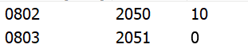

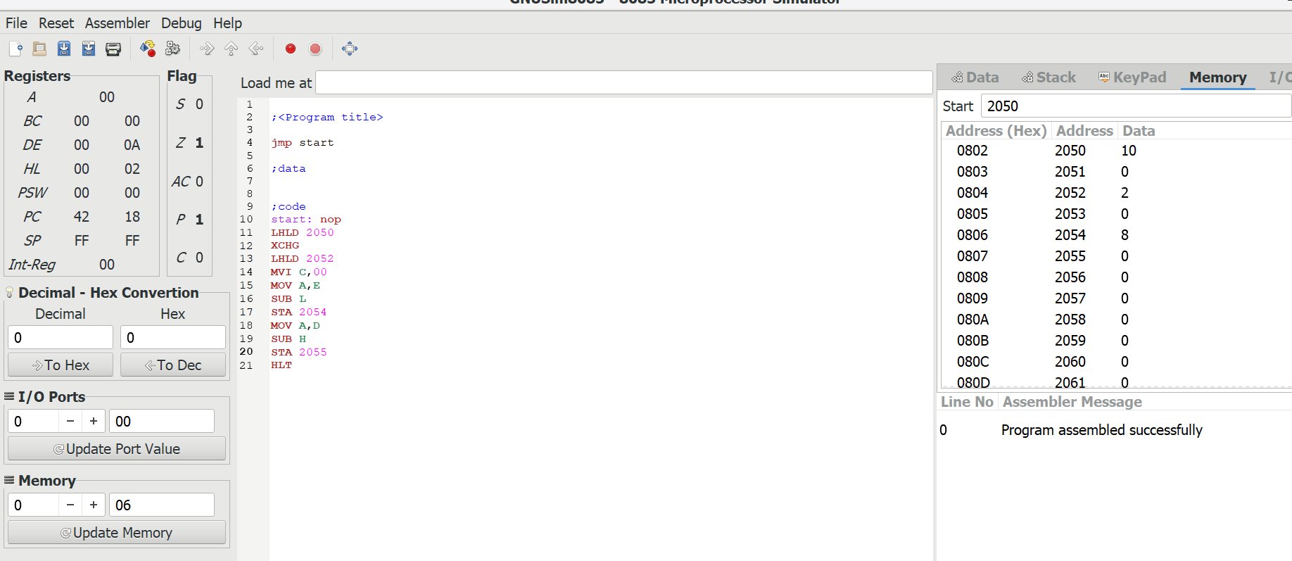

OUTPUT:

RESULT: T

